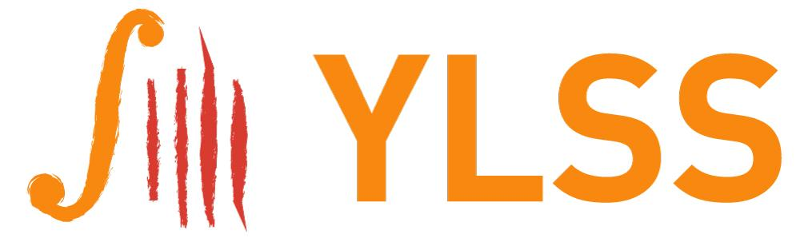
YORKSHIRE LATE STARTERS STRINGS
New Music Competition 2025-26
Entry Form

Composer’s name:____________________________________________________________

Address:_____________________________________________________________________

_____________________________________________________________________________

Phone no:____________________________________________________________________

Email:_______________________________________________________________________

Title of piece:________________________________________________________________

Instrumentation:_____________________________________________________________

Approximate duration:_______________________________________________________

Any additional information:___________________________________________________

Where did you hear about the competition?____________________________________

Would you like YLSS to let you know about future competitions? Yes No

- I agree to the terms of the competition set out in the brief.
- I confirm that, if shortlisted, I am willing and able to take part in the
Workshop on Sunday 16 Nov 2025 in Wetherby.
- I certify that the attached piece is all my own work and has not been composed
in its entirety using AI.

Signed:__________________________________________Date:________________

Please send your entry by 31 July 2025:
∙ Entry form
∙ Pdf, or 4 paper copies, of the score, with no identifying marks
∙ Brief programme note (100-200 words), also anonymous
∙ Short biography, including musical education/background

Send to jenny@jennybrierley.com | or | YLSS New Music, 1 Meeting House Lane,  Acomb, York YO26 5FD
Registered Charity No. 1088105

